Algebra 2 – Graphing Rational Functions Name ____________________
Graph the function, including asymptotes. Identify the transformations, domain, and range.
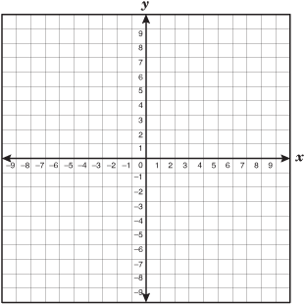
- $y= \frac{2}{x}$ 2. $y= \frac{-1}{x+3}-2$

Domain: Domain:
Range: Range:

- $y= \frac{3}{x+1}+2$ 4. $y= \frac{-4}{x+2}-1$

Domain: Domain:
Range: Range:
Graph the function, including asymptotes. Identify the domain and range.
5. $y= \frac{.5}{x+4}$ 6. $y= \frac{-1}{x-3}+1$

Domain: Domain:
Range: Range:

- $y= \frac{3}{x+1}-2$ 8. $y= \frac{-4}{x-2}+2$

Domain: Domain:
Range: Range:

