Algebra 2 – Graphing Rational Functions Name ____________________
Graph the function, including asymptotes. Identify the domain and range.
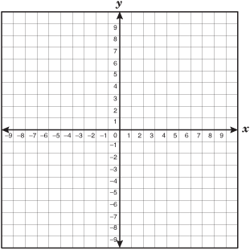
- $y= \frac{1}{x-2}$ x = y = 2. $y= \frac{3}{x}+1$ x = y =

Domain: Domain:
Range: Range:
Transformation: Transformation:
- $y= \frac{-.5}{x+1}$ x = y = 4. $y= \frac{4}{x-1}+2$ x = y =

Domain: Domain:
Range: Range:
Transformation: Transformations:
Graph the function, including asymptotes. Identify the domain and range.
5. $y= \frac{2x}{x+4}$ x = y = 6. $y= \frac{x-1}{2x-3}$ x = y =

Domain: Domain:
Range: Range:

- $y= \frac{3x+1}{2x+1}$ x = y = 8. $y= \frac{-4x}{2x-2}$ x = y =

Domain: Domain:
Range: Range:

