Algebra 2 – Quiz on Inverses Name ____________________
1. Fill in the table so it represents the inverse of f(x).
x  f(x) | 1 | 2 | 3 | 4 | 5 | 6
y | 2 | 4 | 6 | 8 | 10 | 12

x
f⁻¹(x)
y

2. Find the inverse of f(x). Then graph both functions on the same grid.
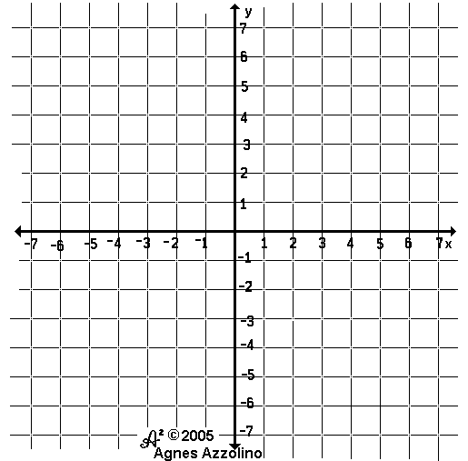
f(x) = 2x – 1

3. Find the inverse of g(x). Then graph both functions on the same grid.
g(x) = ½ x²

4. Find the inverse of h(x). Then graph both functions on the same grid.
h(x) = 0.5x³

5. Find the inverse of f(x) = ¼ x + 3

6. Find the inverse of g(x) = ¹/₅ x²

7. Find the inverse of h(x) = – 3x³

E.C. Pick problem 5, 6, or 7 and prove algebraically they are inverses of each other.

