**Alg2 CC Chapter 3 Review for Test Name: __________________**

Date: ___________ HR: _____

*Follow the directions to solve the following polynomial.*

1. Multiply (b + 1)(b2 + 2b + 3) .

2. Add. (8 + 7*ac*) – ( – 6*ac* – 3) + (–8*ac* – 3)

3. What is the transformation of the graph of  that yields f(x) = -3( x + 4)3 + 5 ?

1. Find the perimeter of a triangle having sides 5x, 2x + 3, and 4x – 1
2. A rectangle has a base of 5*a*2*c* and a height of 3*a*3 – 2*ac* + 1. Write and simplify an expression for the area of the rectangle. Show your work.
3. Identify the type of polynomial function f(x) = 5x2 – x + 1
4. If *f*(*x*) is an even function with a negative leading coefficient, *g*(*x*) is an odd function with a negative leading coefficient, label the two graphs that represent f(x) and g(x).

|  |  |  |  |
| --- | --- | --- | --- |
| a. |  | c. |  |
| b. |  | d. |  |

1. Graph f(x) = x3 + 8x2 + 11x – 20 . Identify the zeros if there are any and give the domain and range. State the end behavior of the graph. Give the max and mins.



1. Draw a graph of an even function with exactly two real zeros and a positive leading coefficient.

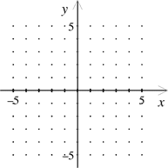

1. Subtract . (4x2 – 7x) – (2x2 – 6x)
2. Multiply (2x + 3)(-4x – 2)
3. Multiply ${\left(3x+2\right)}^{2}$

1. Explain the difference of what an even degree graph with a negative leading coefficient looks like compared to an odd degree graph with a negative leading coefficient. Make a sketch of each graph before writing the explanation.
2. **Graph each function and describe the transformations.**

**a.** f(x) **=** x3 - 1  **b.**  h(x) = (x + 2)4 - 1

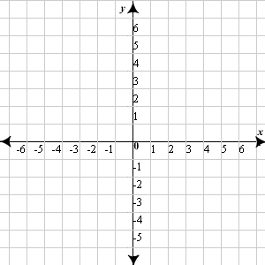

1. **Graph each function and describe the transformations.**

**a.** f(x) **= -2**x2 - 1  **b.**  h(x) = 1/3 (x + 2)3 - 1



1. Identify the degree and the leading coefficient of f(x) = 5x2 – 4x3 + 12 – 3x .
2. Which function is not a polynomial function? EXPLAIN why!!

|  |  |
| --- | --- |
| a. | f(x) = 3x4 – 5x + 7 |
| b. | f(x) = x3 + 2x2 – 6x + 1 |
| c. | f(x) = 2x2 – 9x + 7/x + 8 |
| d. | f(x) = x2 + 4x + 3 |