Worksheet 5-3 Inverses of Cubic Functions
- Graph the function and the inverse of $f\left(x\right)=-\frac{1}{2}x^{3}$
Inverse ___________________
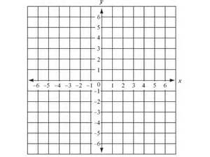
- The function $t\left(w\right)=\frac{w^{3}}{9}$ gives the number of full truckloads t of cement needed to form a bridge pillar of width w yards. Write and graph the inverse function w(t) to find the approximate width of a pillar requiring t truckloads of cement. Then estimate the width of a bridge pillar requiring 40 truckloads of cement.
Inverse ___________________
Describe the graph of each function as a transformation of the graph of the parent cube root functions

- $g\left(x\right)=5\sqrt[3]{x}$
- $g\left(x\right)=\sqrt[3]{3x}$

