Worksheet on Box Plots Name ____________________
Listed below are the scores for a midterm exam:
57, 59, 60, 62, 65, 71, 74, 78, 80, 81, 83, 84, 88, 95, 99
Find the five statistical values below.
Minimum | First Quartile | Median | Third Quartile | Maximum

Determine whether the data set has any outliers
Q1 – 1.5(IOR)= Q3 + 1.5(IQR) =

Outliers, if any ________________

Complete a box plot. Remember a title!
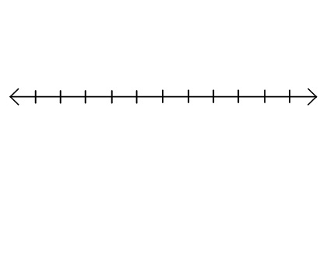

Describe the shape of the distribution _____________________________

Listed below are the scores for a final exam:
51, 53, 69, 75, 75, 78, 79, 90, 81, 81, 82, 85, 85, 88, 90
Find the five statistical values below.
Minimum | First Quartile | Median | Third Quartile | Maximum

Determine whether the data set has any outliers
Q1 – 1.5(IOR)= Q3 + 1.5(IQR) =

Outliers, if any ________________

Complete a box plot. Remember a title!

Describe the shape of the distribution _____________________________

